**GENERAL QUERIES ACTIONS**

|  |  |
| --- | --- |
| Date | 10 November 2022 |
| Team ID | PNT2022TMID52869 |
| Project Name | AI based discourse for Banking Industry |
| Maximum Marks | 10 Marks |

To create the general queries action IBM services are required. The services employed include **IBM Cloud** and **IBM Watson Assistant**.

**CREATED:**

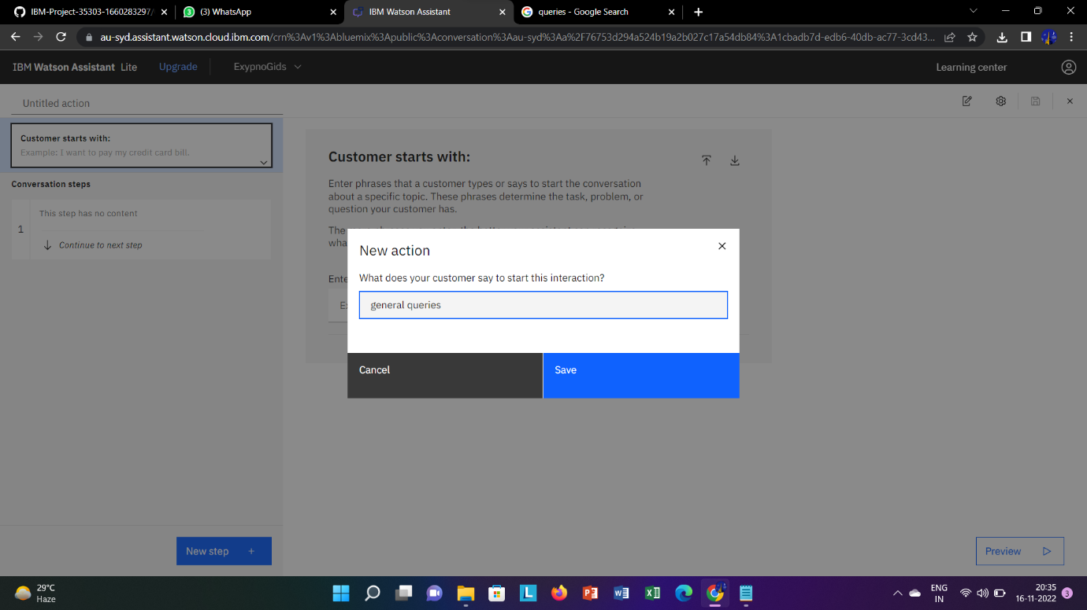

**ACTIONS:**

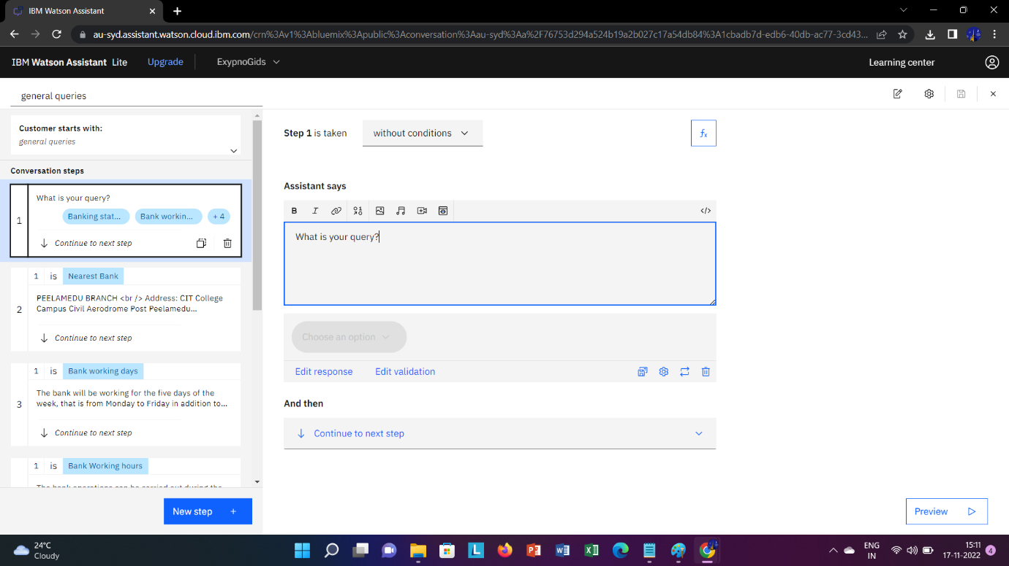

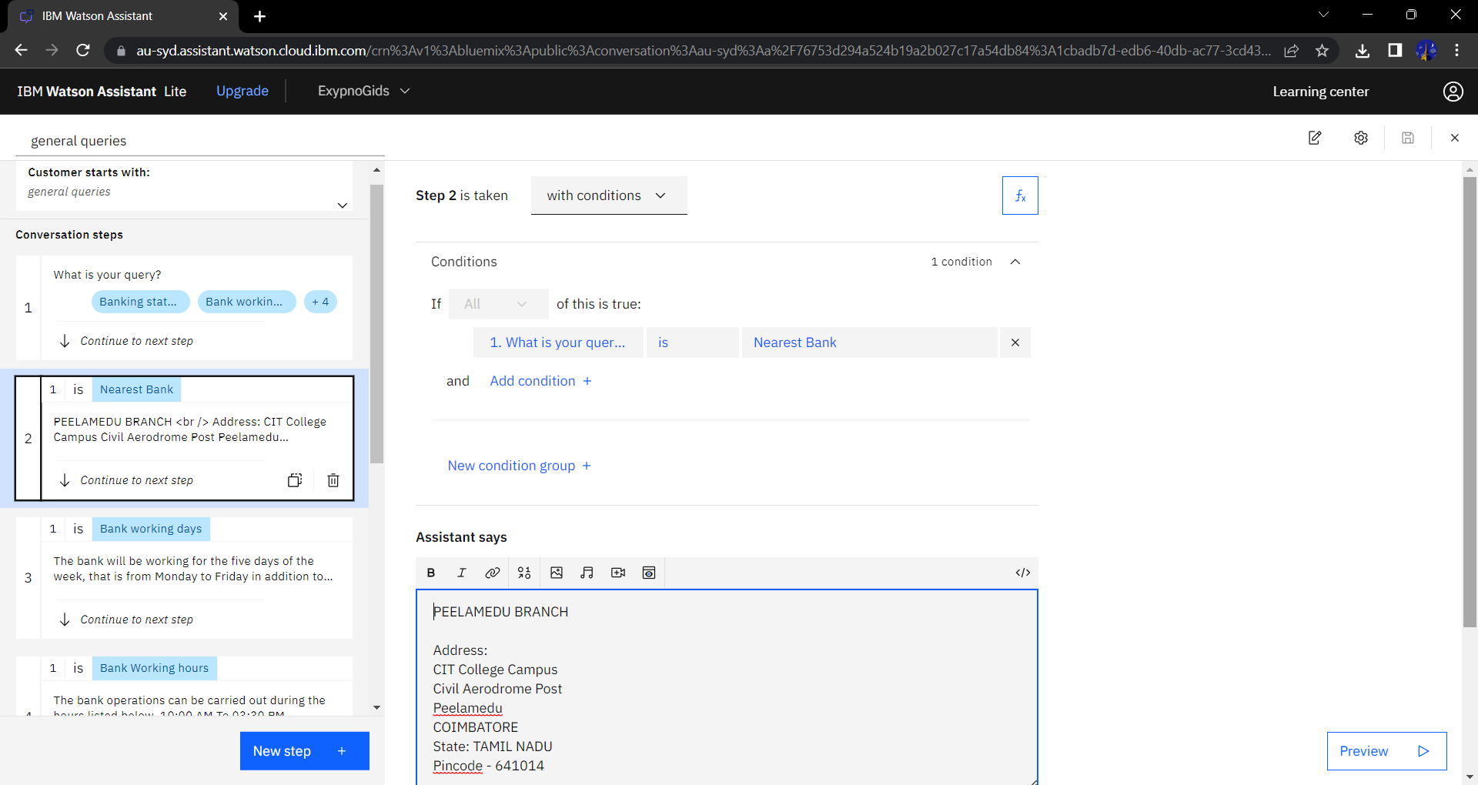

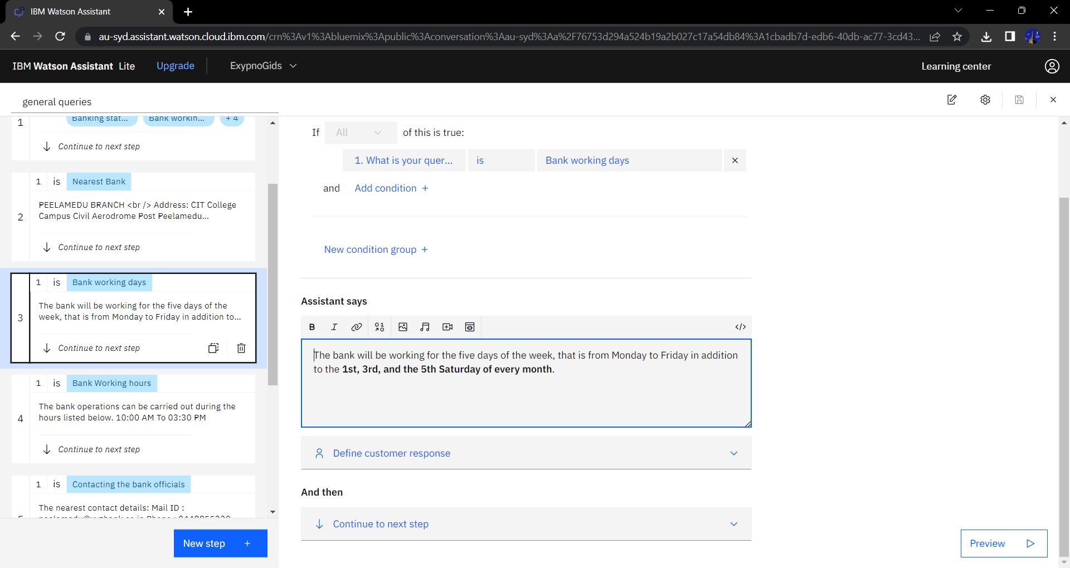

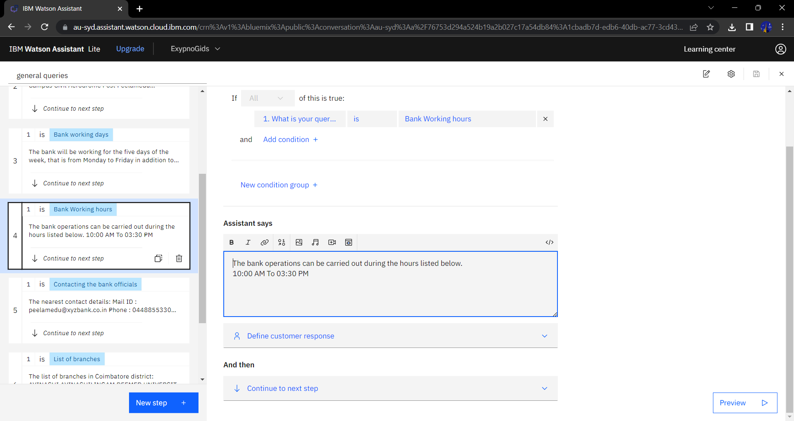

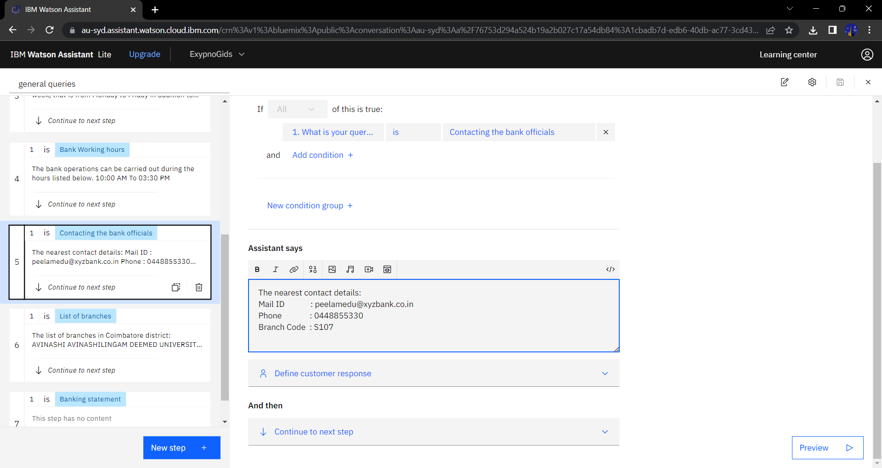

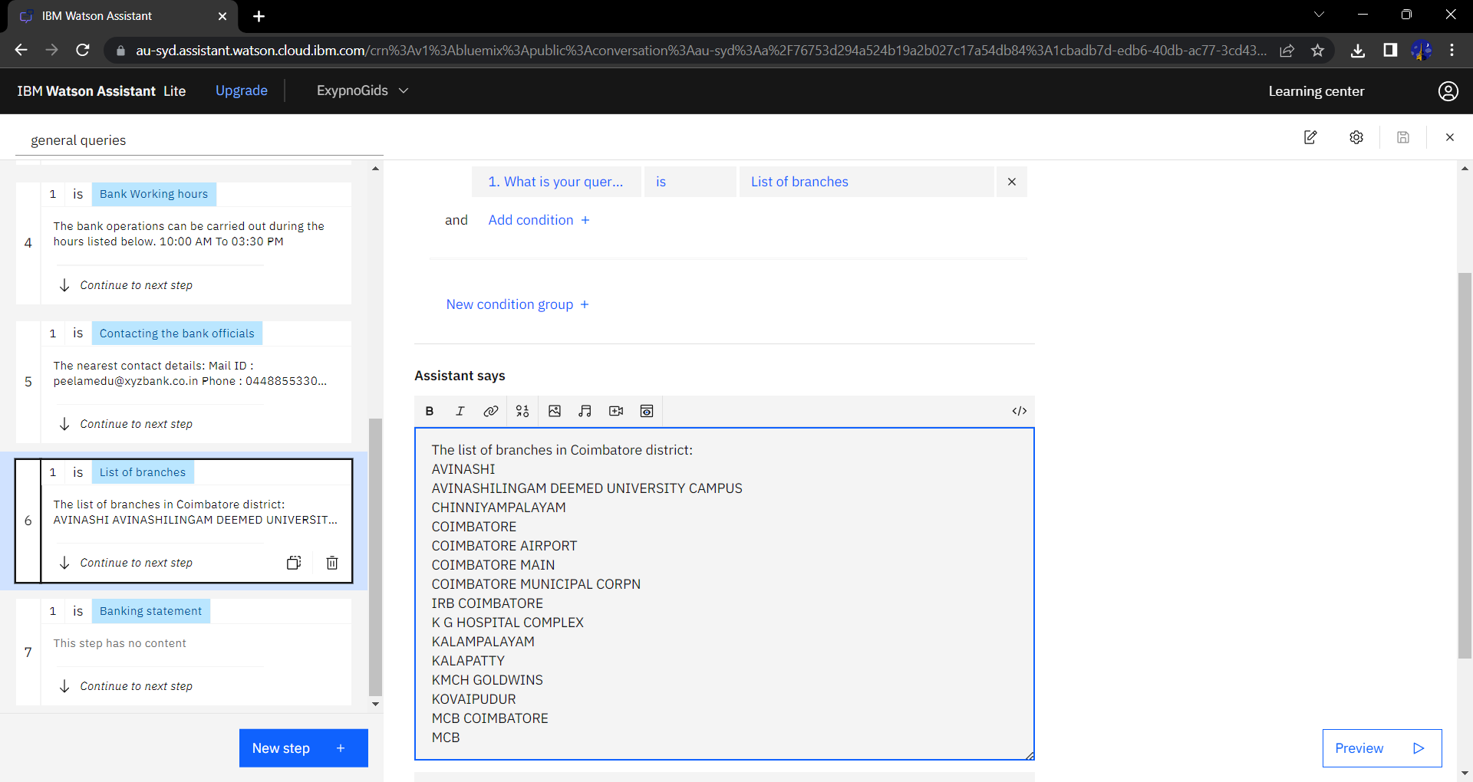

**PREVIEW:**

